Alyssiah Shannon
Santa Fe, NM
February 12, 2026
WK Kellogg Co

Jean-Baptiste Santoul
Chief Operating Officer
1 Kellogg Square
Battle Creek, Michigan 49017, US

Dear Jean-Baptiste Santoul,
I am writing this email to you as I am deeply concerned about your companies’ racial views. Recently, I bought your Corn Pops cereal and was horrified by the seemly racist implications on the cereal box. Out of all the characters on the cereal box, the only one that is colored is in a janitorial position. Everyone else is the obvious Corn pop color that is usually advertised on the box. I am afraid that this example will give my children and other children alike a negative view of people of color.
Additionally, I will not be buying any more cereal from your brand. It is a shame because my children enjoy eating your cereal. If you can remove the artwork and replace it with a different one, I would be happy to invest back into your brand in the future. As it stands, I will no longer be buying Kellogg’s cereal. Thank you for your time. I can be reached at 555-555-5555. My email is ashannon1234@unm.edu.
Alyssiah Shannon,
A customer for over 10 years

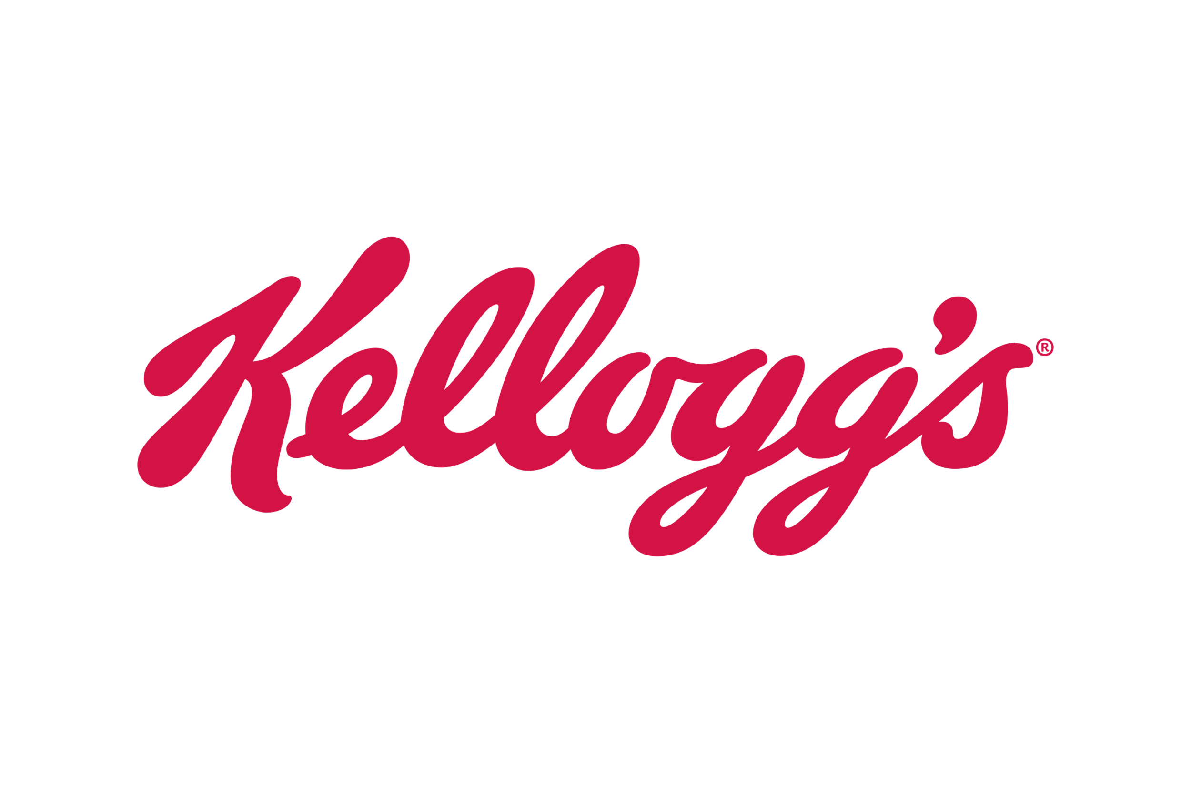
WK Kellogg Co
Jean-Baptiste Santoul
Chief Operating Officer
1 Kellogg Square
Battle Creek, Michigan 49017, US

Alyssiah Shannon
Santa Fe, NM
February 13th, 2026

Dear Alyssiah,
Thank you for bringing this issue to my attention. I sincerely apologize for the offensive artwork on the Corn Pops cereal box.
I have reached out to our marketing team, and they are creating a new design for the cereal box. The old artwork will be replaced with a new one in all stores that sell our cereal as soon as possible.
We did not have any intention on creating artwork that would make a negative impact on you or anyone that may have been affected by the artwork. We are committed to providing inclusive products that everyone can enjoy.
In addition, on behalf of the company and myself, we would love to send you and your family one-month free supply of Corn Pops cereal for the inconvenience. Thank you for being a valued customer and I look forward to hearing back from you soon. For any additional questions, please reach out to me at (555) 123-5678 and my email is kelloggcoo@gmail.com.
Best Wishes,
Jean-Baptiste Santoul

Chief Operating Officer
1 Kellogg Square
Battle Creek, Michigan 49017, US

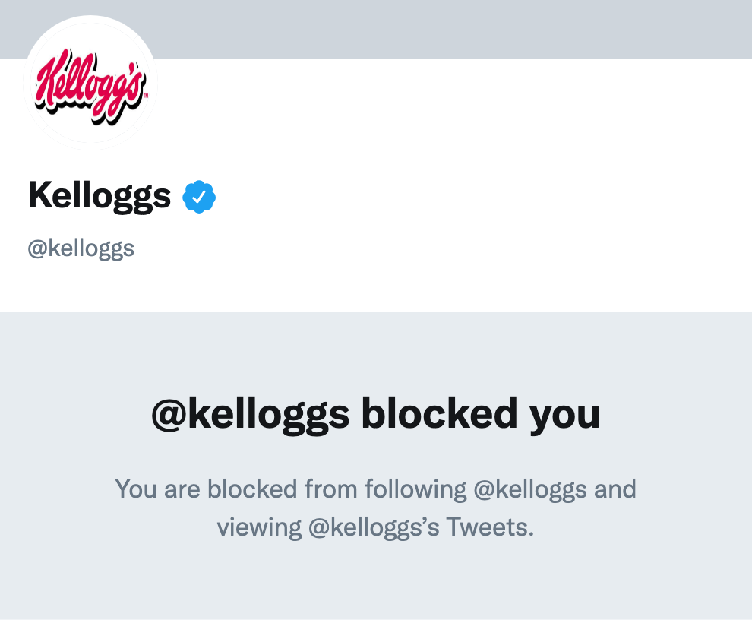
We understand the severity of the situation and we are working on removing boxes that have the old artwork off grocery store shelves. We apologize for the misrepresentation and artwork that was unintentionally offensive to our growing community and support network.

We sincerely apologize how this artwork has affected the community, and we are working replacing it as soon as possible. This artwork was not intended to offend others, and we are deeply sorry for this experience.
Reflective

